Dr. Omyma Galal Ahmed
Physiological Department
Faculty of Medicine
Assiut Universitry
Egypt
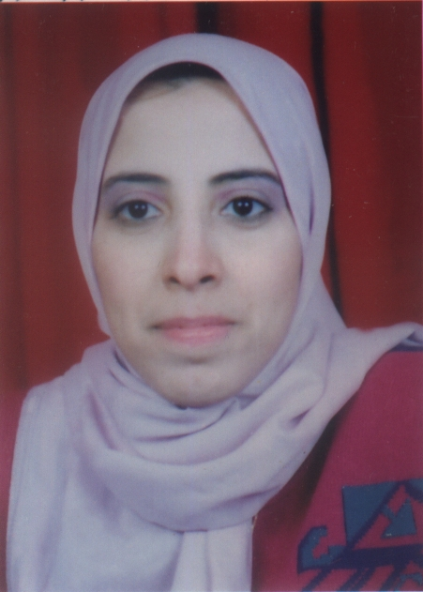

Curriculum Vitae

Name: Omyma Galal Ahmed Moety.
Date of birth: 5/11/1967.
Nationality: Egyptian.
Religion: Moslem.
Passport No: 1240582
Social state: married and have 4 children.
Address: Egypt – Assiut – 17 EL-Shabat EL-Moslemat Street behind the Agriculture Secondary School.
Tel: 088/337630 Mobile: 01006807029
E mail: Omyma_galal@hotmail.com

Education:
- M.B.B.C.H. Faculty of Medicine Assuit University September 1992
- Master Degree of Physiology Faculty of Medicine Assuit University 28 / 12/1997.
- Attendance of an intensive workshop in modern techniques of molecular biology and their applications on 19 – 22 / 4 / 1999.
- Attendance of an institutional testing program of TOEFL on January 2000.
- Attendance of an advanced level of English language program on April 2001.
- Doctor Degree of Physiology Faculty of Medicine Assuit University 25/ 5/ 2003.
Postgraduate Courses and experience:
- Training Doctor in Assuit University Hospital from 1/ 3/ 1993 to 28 / 2 / 1994.
- Resident in internal medicine department - Assuit University Hospital from 1/3/1994 to 3/8/1994.
- Demonstrator of Physiology in Faculty of Medicine Assuit University from 4/8/1994.
- Assistant Lecturer of Physiology in Faculty of Medicine Assuit University from 12 / 2 / 1998.
- Lecturer of Physiology Faculty of Medicine Assuit University from 29/6/2003.
- Assistant Professor of Physiology Faculty of Medicine Assuit University from
29/6/2008.
- Professor of Physiology Faculty of Medicine Assuit University from
29/6/2013.

University Teaching
- Sharing in teaching of the theoretical and practical courses of general and special Cardiovascular System and Respiratory System to first year Medicine, Assiut, Sohag and Azhar Universities.
- Sharing in teaching of theoretical and practical courses of the Endocrine system, Central Nervous System Kidney, Special Senses and General Metabolism to second year Medicine and Veterinary Medicine, Assiut, Sohag and South Valley Universities.
- Sharing in teaching of the theoretical and practice courses of Respiratory system to first year of Veterinary Medicine Assiut University.
- Sharing in teaching of the theoretical and practice courses of renal and digestive systems to the first year of Pharmacy Assiut University.
Projects
- Involved in the management team of the project titled: Higher Education Enhancement.
- Sharing in the project titled: Assiut University Medical Education Development.

Workshops and Training Cources
- A workshop was attended on modern techniques of molecular biology and their applications, Assiut University, Assiut, Egypt, 19 – 22 / 4 / 1999.
- A workshop was attended on Tissue culture and Immunostaining Assiut University, Assiut, Egypt, 13-15 / 11 /2005.
- A workshop was attended on protein analysis Assiut University, Assiut, Egypt, /2010
- A workshop was attended on tissue culture 22/3/2015
Supervision
Participating in four Ph. D. theses, and five Master theses

Memberships and Other Activities
Member of the clinical physiological Society.
Member of Assiut University Staff Members Club.

Reviewer
Participate as a reviewer in the annual conference of the faculty of medicine under a title: (physiological sequences of aging).

LIST OF PUBLICATIONS:
*1-Publication of a paper from the Ph. D. Thesis with a title:
Effect of Melatonin on Parkinson Like Syndrome Induced by 1-methyl-4-phenyl Tetrahydropyridine in mice

*2- Publication of a paper in Assiut Medical Journal With a title:
The actions of honey on male mice testes exposed to carbon tetra-chloride (CCL4) Physiological and histological studies.

* 3- Central and peripheral contributions to physical and electrical fatigue. In: Bulletin of Egyptian Society for physiological sciences, 26(1) 101-118, 2006.

* 4-Study of anticonvulsant effects of some steroids on induced seizers in mice. In Assiut Medical Journal.

*5-Lack of post exercise depression of corticospinal excitability in patients with parkinson's disease. In: European Journal of Neurology 2007. (In Press).
* 6- Intake of melatonin is associated with amelioration of physiological changes, both metabolic and morphological pathologies associated with obesity: an animal model. In: International Journal of Experimental Pathology 2006 (In Press).

*7- Association between serum IGF-1, TNF-α, IL-6 and lipids with serum iron in both acute myocardial infarction and unstable angina patients. In: Bulletin of Egyptian Society for physiological sciences, 27(1): 291-316, 2007.

*8-Importance of inflammatory cytokines and endothelial peptides in predicting hypertensive left ventricular hypertrophy. Assiut Medical Journal,32(1):89-102, 2008.

* 9-Haemodynamic Response to Iron Deficiency, Thalassaemia and Sickle Cell Anemia

Tahia H. Saleem, Osama A. Ibrahiem*, Omyma G. Ahmed**, Hoyida A. Nafady*, and Mohamed R. Abd-Elhameed. Assiut Medical Journal, (2009)

* 10-Impact of Selective Cyclooxygenase-2 Inhibition on the Pathophysiology
of Atherosclerosis and Unstable Angina
Mahmoud R. Abdel-Fadeil, Yehia T. Kishk, Omyma G. Ahmed, Dalia Gamal. Ibnosina J Med BS 2011,3(3). 146-151.

* 11-The Impact of Insulin-like Growth Factor-1, Growth Hormone, and Oxidative Stress in the Experimental Model of Juvenile and Adult Hypothyroid Retinal Degeneration
Omyma G Ahmed, Amal Taha and Faten Y Mahmoud. Ibnosina J Med BS 2011,3(5):150-
164.

* 12-Interplay of insulin resistant and the reproductive and metabolic changes in women with Polycystic Ovary Syndrome .
Asmaa F Hassan , Omyma G Ahmed ,Marwa A Ahmed, and Hosam O Hamed
Accepted in Ibnosina J Med BS at date 3-10-2011

* 13- Immune Modulating Effects of Malathion with the Role of Bradykinin
Potentiating Factor in Juvenile Male Rats
Omyma G. Ahmed, Ibnosina J Med BS ( 2012) ;4(5):151-169.

14- Renal function and arterial blood pressure alterations after exposure to acetaminophen with a potential role of Nigella sativa oil in adult male rats
Omyma G Ahmed & Nashwa Aly Abd El-Mottaleb Assiut University, Assiut, Egypt. J Physiol Biochem (2013), 69:1-13.

15- Inflammation Versus Oxidative Stress in Pathophysiology of Alzheimer’s Disease in Rat Model
Omyma Galal Ahmed1, Hayam Zakaria Thabet2, Aml Aly Mohamed2 Ibnosina J Med BS 2014;6(3):130-144.

16- The Impact of Vitamin E Supplementation on Urinary Bladder
Contractility in Streptozotocin-Induced Diabetic Rats
Marwa A. Ahmed, Asmaa F. Hassan and Omyma G. Ahmed . Ibnosina J Med BS (2013) ;5(1):4-14.

17- Adipocytokines, growth factors and oxidative markers Alterations in Lead Induced intrauterine growth retardation in Albino rats with potential role of melatonin
Omyma G Ahmed and Eman Ahmed Negm Bull. Egypt. Soc. Physiol. Sci. (2012); 32(2);223:242.

1 18- Integral relationship of some adipocytokines with glycaemic control and cardiovascular risks in type 2 diabetes mellitus with application of incretin enhancer

Omyma G. Ahmed and Osama A. Ibrahiem*, Assiut Medical Journal (2013);37(1):201

19- Deterioration of Testicular Functions in Adult Male Rabbit After Exposure to Mobile Phone Radiation With Impending Recovery

Omyma G. Ahmed, Nagwa S. Ahmed *, Nawal Badawy** and Mohamed Ashraf .

Assiut Medical Journal (2013), 37(1): 257-268

20- Impact of oxytocin with or without acupuncture analgesia: experimental and clinical studies
Omyma G. Ahmed₁, Mohamed Awad₁, Amel Taha_{2,} Ebtehal Anwer ₁, Ayman M.Osman₃, Nessren M₁ Assiut Medical Journal (2014), 37(1)

****************************

